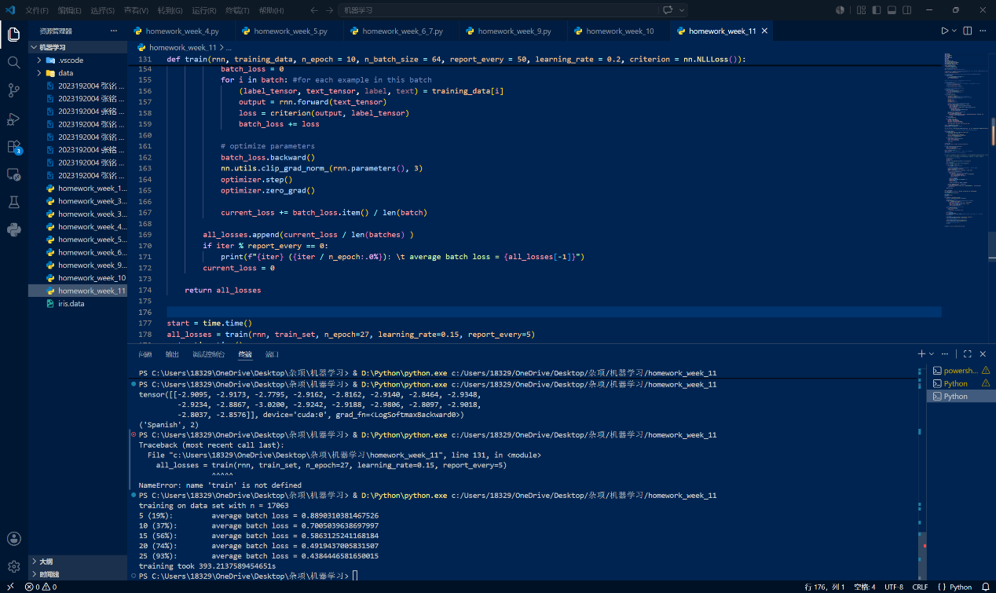
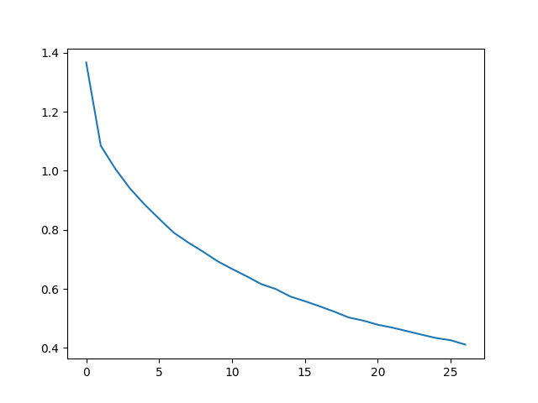
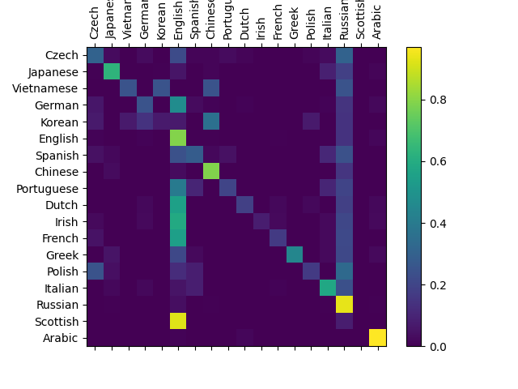

import torch
import string
import unicodedata
import random
import numpy as np
from io import open
import glob
import os
import time
import torch.nn as nn
import torch.nn.functional as F
from torch.utils.data import Dataset
import matplotlib.pyplot as plt
import matplotlib.ticker as ticker
# Check if CUDA is available
device = torch.device('cpu')
if torch.cuda.is_available():
device = torch.device('cuda')

torch.set_default_device(device)
#print(f"Using device = {torch.get_default_device()}")

# We can use "_" to represent an out-of-vocabulary character, that is, any character we are not handling in our model
allowed_characters = string.ascii_letters + " .,;'" + "_"
n_letters = len(allowed_characters)

# Turn a Unicode string to plain ASCII, thanks to https://stackoverflow.com/a/518232/2809427
def unicodeToAscii(s):
return ''.join(
c for c in unicodedata.normalize('NFD', s)
if unicodedata.category(c) != 'Mn'
and c in allowed_characters
)

#print (f"converting 'Ślusàrski' to {unicodeToAscii('Ślusàrski')}")

# Find letter index from all_letters, e.g. "a" = 0
def letterToIndex(letter):
# return our out-of-vocabulary character if we encounter a letter unknown to our model
if letter not in allowed_characters:
return allowed_characters.find("_")
else:
return allowed_characters.find(letter)

# Turn a line into a <line_length x 1 x n_letters>,
# or an array of one-hot letter vectors
def lineToTensor(line):
tensor = torch.zeros(len(line), 1, n_letters)
for li, letter in enumerate(line):
tensor[li][0][letterToIndex(letter)] = 1
return tensor

class NamesDataset(Dataset):

def __init__(self, data_dir):
self.data_dir = data_dir #for provenance of the dataset
self.load_time = time.localtime #for provenance of the dataset
labels_set = set() #set of all classes

self.data = []
self.data_tensors = []
self.labels = []
self.labels_tensors = []

#read all the ``.txt`` files in the specified directory
text_files = glob.glob(os.path.join(data_dir, '*.txt'))
for filename in text_files:
label = os.path.splitext(os.path.basename(filename))[0]
labels_set.add(label)
lines = open(filename, encoding='utf-8').read().strip().split('\n')
for name in lines:
self.data.append(name)
self.data_tensors.append(lineToTensor(name))
self.labels.append(label)

#Cache the tensor representation of the labels
self.labels_uniq = list(labels_set)
for idx in range(len(self.labels)):
temp_tensor = torch.tensor([self.labels_uniq.index(self.labels[idx])], dtype=torch.long)
self.labels_tensors.append(temp_tensor)

def __len__(self):
return len(self.data)

def __getitem__(self, idx):
data_item = self.data[idx]
data_label = self.labels[idx]
data_tensor = self.data_tensors[idx]
label_tensor = self.labels_tensors[idx]

return label_tensor, data_tensor, data_label, data_item

alldata = NamesDataset("data/names")
#print(f"loaded {len(alldata)} items of data")
#print(f"example = {alldata[0]}")

train_set, test_set = torch.utils.data.random_split(alldata, [.85, .15], generator=torch.Generator(device=device).manual_seed(2024))

#print(f"train examples = {len(train_set)}, validation examples = {len(test_set)}")

class CharRNN(nn.Module):
def __init__(self, input_size, hidden_size, output_size):
super(CharRNN, self).__init__()

self.rnn = nn.RNN(input_size, hidden_size)
self.h2o = nn.Linear(hidden_size, output_size)
self.softmax = nn.LogSoftmax(dim=1)

def forward(self, line_tensor):
rnn_out, hidden = self.rnn(line_tensor)
output = self.h2o(hidden[0])
output = self.softmax(output)

return output

n_hidden = 128
rnn = CharRNN(n_letters, n_hidden, len(alldata.labels_uniq))
#print(rnn)

def label_from_output(output, output_labels):
top_n, top_i = output.topk(1)
label_i = top_i[0].item()
return output_labels[label_i], label_i

input = lineToTensor('Albert')
output = rnn(input) #this is equivalent to ``output = rnn.forward(input)``
#print(output)
#print(label_from_output(output, alldata.labels_uniq))

def train(rnn, training_data, n_epoch = 10, n_batch_size = 64, report_every = 50, learning_rate = 0.2, criterion = nn.NLLLoss()):
"""
Learn on a batch of training_data for a specified number of iterations and reporting thresholds
"""
# Keep track of losses for plotting
current_loss = 0
all_losses = []
rnn.train()
optimizer = torch.optim.SGD(rnn.parameters(), lr=learning_rate)

start = time.time()
print(f"training on data set with n = {len(training_data)}")

for iter in range(1, n_epoch + 1):
rnn.zero_grad() # clear the gradients

# create some minibatches
# we cannot use dataloaders because each of our names is a different length
batches = list(range(len(training_data)))
random.shuffle(batches)
batches = np.array_split(batches, len(batches) //n_batch_size )

for idx, batch in enumerate(batches):
batch_loss = 0
for i in batch: #for each example in this batch
(label_tensor, text_tensor, label, text) = training_data[i]
output = rnn.forward(text_tensor)
loss = criterion(output, label_tensor)
batch_loss += loss

# optimize parameters
batch_loss.backward()
nn.utils.clip_grad_norm_(rnn.parameters(), 3)
optimizer.step()
optimizer.zero_grad()

current_loss += batch_loss.item() / len(batch)

all_losses.append(current_loss / len(batches) )
if iter % report_every == 0:
print(f"{iter} ({iter / n_epoch:.0%}): \t average batch loss = {all_losses[-1]}")
current_loss = 0

return all_losses

start = time.time()
all_losses = train(rnn, train_set, n_epoch=27, learning_rate=0.15, report_every=5)
end = time.time()
print(f"training took {end-start}s")

plt.figure()
plt.plot(all_losses)
plt.show()

def evaluate(rnn, testing_data, classes):
confusion = torch.zeros(len(classes), len(classes))

rnn.eval() #set to eval mode
with torch.no_grad(): # do not record the gradients during eval phase
for i in range(len(testing_data)):
(label_tensor, text_tensor, label, text) = testing_data[i]
output = rnn(text_tensor)
guess, guess_i = label_from_output(output, classes)
label_i = classes.index(label)
confusion[label_i][guess_i] += 1

# Normalize by dividing every row by its sum
for i in range(len(classes)):
denom = confusion[i].sum()
if denom > 0:
confusion[i] = confusion[i] / denom

# Set up plot
fig = plt.figure()
ax = fig.add_subplot(111)
cax = ax.matshow(confusion.cpu().numpy()) #numpy uses cpu here so we need to use a cpu version
fig.colorbar(cax)

# Set up axes
ax.set_xticks(np.arange(len(classes)), labels=classes, rotation=90)
ax.set_yticks(np.arange(len(classes)), labels=classes)

# Force label at every tick
ax.xaxis.set_major_locator(ticker.MultipleLocator(1))
ax.yaxis.set_major_locator(ticker.MultipleLocator(1))

# sphinx_gallery_thumbnail_number = 2
plt.show()

evaluate(rnn, test_set, classes=alldata.labels_uniq)

